# Assignment -4

SMS SPAM Classification

|  |  |
| --- | --- |
| Assignment Date | 21 November 2022 |
| Student Name | P.Atchaya |
| Student Roll Number | 820519106015 |
| Maximum Marks | 2 Marks |

# Question-1:

Download the dataset

# Question-2:

Import required library

**Solution** import nltk import pandas as pd import re

from nltk.corpus import stopwords from nltk.stem.porter import PorterStemmer from sklearn.feature_extraction.text import CountVectorizer from sklearn.model_selection import train_test_split from tensorflow.keras.models import Sequential from tensorflow.keras.layers import Dense

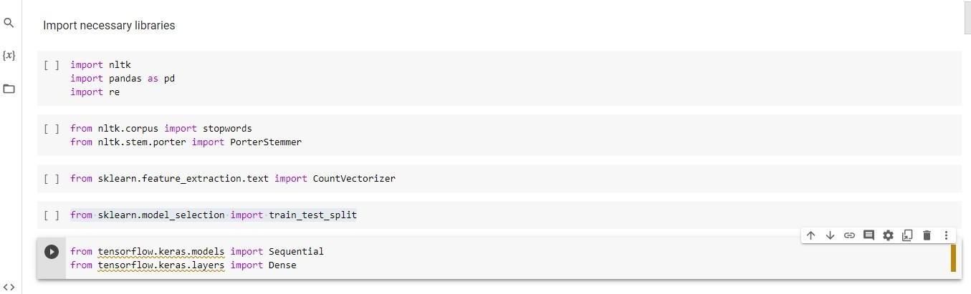

# Question-3:

Read dataset and do pre-processing

# Solution

data=pd.read_csv('/content/drive/MyDrive/assignment 4/spam.csv',encoding='latin') nltk.download('stopwords') ps=PorterStemmer() input=[] for i in range(0,5572): review=data['v2'][i] review=re.sub('[^a-zA-Z]',' ',review)

review=review.lower() review=review.split() review=[ps.stem(word) for word in review if not word in set(stopwords.words('english'))] review=' '.join(review) input.append(review) cv=CountVectorizer(max_features=7000) x=cv.fit_transform(input).toarray() y=data['v1'].values x_train,x_test,y_train,y_test= train_test_split(x,y,test_size=0.2)

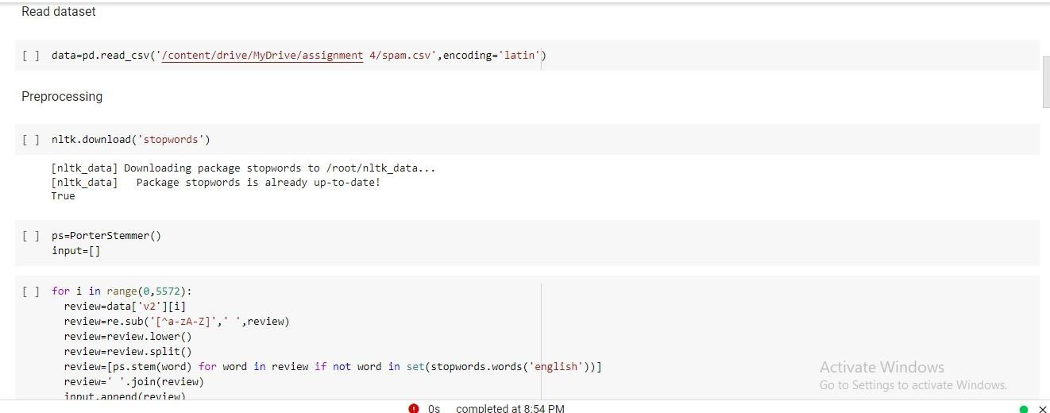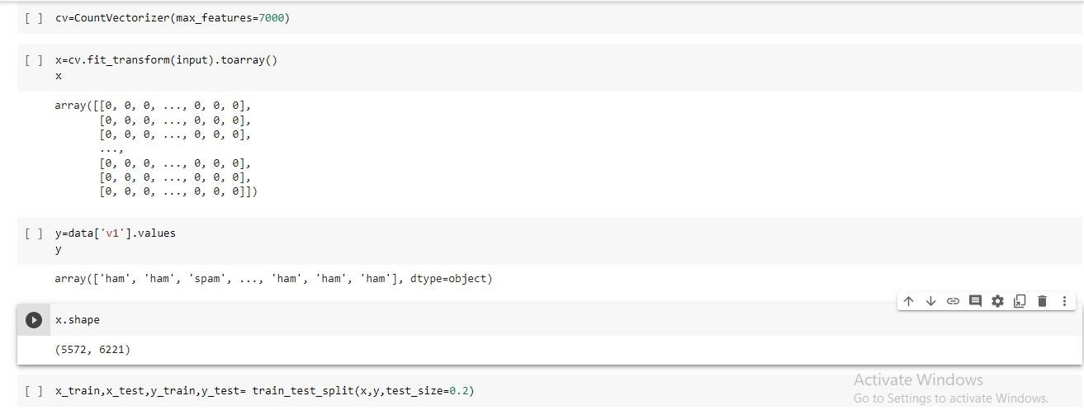

# Question-4:

Create Model

# Solution

model=Sequential()

# Question-5:

Add Layers (LSTM, Dense-(Hidden Layers), Output) **Solution** model.add(Dense(units=6221,activation='relu')) model.add(Dense(units=7000,activation='relu')) model.add(Dense(units=1,activation='sigmoid'))

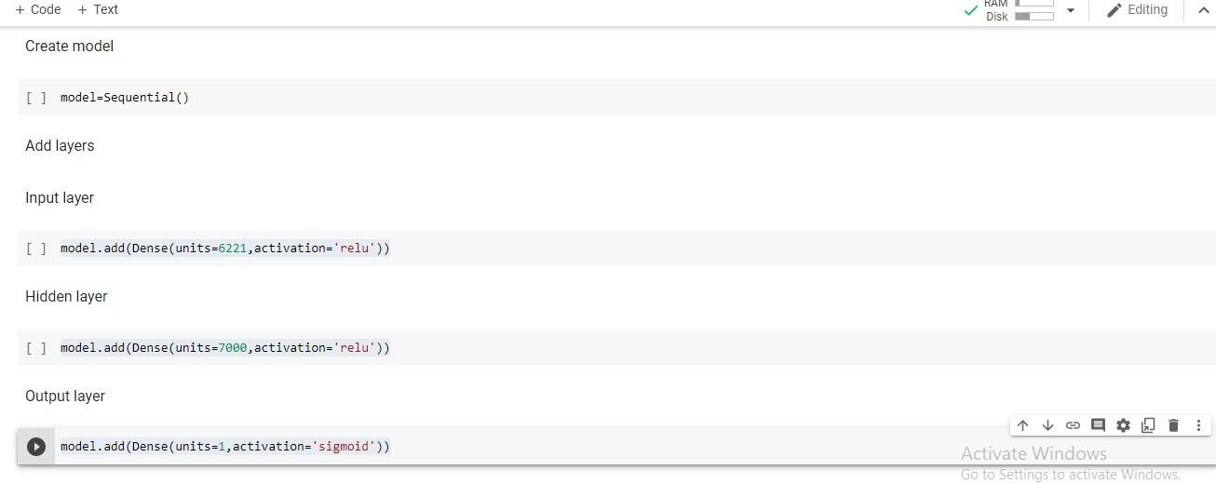

# Question-6:

Compile The Model

# Solution

model.compile(optimizer='adam',loss='binary_crossentropy',metrics=['accuracy'])

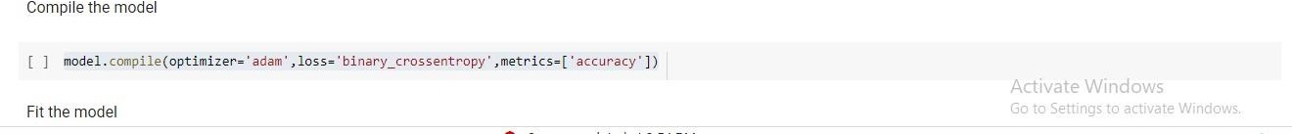

# Question-7:

Fit The Model

# Solution

model.fit(x_train,y_train,epochs=5)



# Question-7:

Save The Model

# Solution

model.save("Flowers.h5")

